|  |  |
| --- | --- |
| Year 9 Science:  Electricity and Thermal Energy Test  ANSWER KEY | |
| Multiple Choice:  Short Answer:  Mark: | ____ / 10  ____ / 52  ____ / 62  ____ % |

**Multiple Choice Answers**

|  |  |  |  |  |  |  |  |  |  |  |
| --- | --- | --- | --- | --- | --- | --- | --- | --- | --- | --- |
| **Question** | **Response** | | | |  | **Question** | **Response** | | | |
| 1 | A | B | C | D |  | 6 | A | B | C | D |
| 2 | A | B | C | D |  | 7 | A | B | C | D |
| 3 | A | B | C | D |  | 8 | A | B | C | D |
| 4 | A | B | C | D |  | 9 | A | B | C | D |
| 5 | A | B | C | D |  | 10 | A | B | C | D |

**Short Answer**

Write your answers in the spaces provided.

**Question 1: Thermal Energy and Temperature**

1. Explain the difference between thermal energy and temperature. (2)

Thermal energy is the movement / vibration of particles OR

Thermal energy is the total amount of energy in an object (1)

Temperature is a measure of the average kinetic energy of particles (1)

1. What is meant by the phrase “thermal equilibrium”? Give an example as part of your response. (3)

One object transfers thermal energy to another until they are the same temperature. (1)

A spoon in a hot drink.

The hot drink has a higher thermal energy than the spoon (1)

Thermal energy is transferred from the drink to the spoon until they are the same temperature. (1)

1. 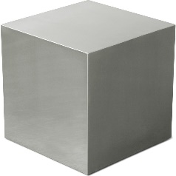Which of the objects has a larger amount of thermal energy? Explain why. (2)

The one on the right has more thermal energy (1)

The volume is the same, but the one on the right has

a higher temperature. (1)

100 g

20°C

100 g

60°C

1. 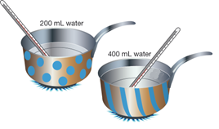200 mL of cold water is heated in the spotted saucepan, and 400 mL of cold water is heated in an identical striped saucepan. If both saucepans are given the same amount of energy, which one will have the larger increase in temperature? Give an explanation for your choice. (2)

The spotted one will have a larger increase in temperature (½) because it has fewer particles / smaller volume (½)

Each particle gets more energy (½) so there is a larger increase in average kinetic energy (½)

**Question 2: Transfer of Thermal Energy**

1. For the situations below, state the form of thermal energy transfer and explain how the energy is transferred. (5)
2. The interior of a room warms up soon after the heater has been turned on.

Convection (½)

The air near the heater warms up (½) and becomes less dense (½)

The warm air rises (½) and is replaced by cooler, more dense air (½)

1. Allan feels his body getting warm as he plays cricket on a summer day.

Radiation (½)

The Sun produces thermal energy (½) which travels through space (½) without heating it (½) Allan’s body then absorbs the thermal energy (½)

1. 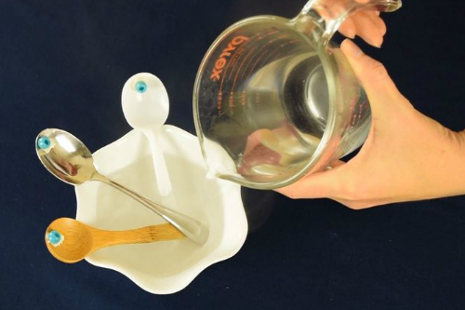A student set up an experiment by sticking a plastic bead to three different spoons with wax. They sat the ends of the spoons in a bowl and then poured hot water into the bowl.
   1. Which method of heat transfer is being used in this situation? Conduction (1)
   2. Out of the three spoons (wood, metal or plastic), which bead should fall off first when the wax melts? Explain your choice. (2)

Metal spoon (1)

Metal is a good conductor of heat, the other two are not (1)

**Question 3: Electrostatic Force**

1. A balloon is rubbed on your hair, transferring electrons to the balloon. Describe the electrostatic charge on each object. (1)

Balloon = negative charge

Hair = positive charge

1. Explain why your hair spreads out when it is electrostatically charged. (2)

All the hair has the same charge / is negatively charged (1)

Two like charges repel so the hair spreads out (1)

1. Explain why your hair is attracted to the balloon. (2)

The hair and the balloon are opposite charges / one positive and one negative (1)

Objects with opposite charges attract (1)

**Question 4: Series and Parallel Circuits**

1. Explain the difference between a series and a parallel circuit. Draw a diagram of each type of circuit with two globes in each. (4)

Series circuits have components on one conducting pathway (1)

Parallel circuits have components on more than one conducting pathway (1)

Appropriate diagrams (1 each)

1. Compare the brightness of globes in series and in parallel to the brightness of a single globe. (2)

Globes in series are dimmer than / not as bright as a single globe (1)

Globes in parallel are the same brightness as a single globe (1)

1. What type of circuits are used in houses? Give two reasons why these circuits are used. (3)

Parallel circuits are used in houses (1)

Reasons include: (any 2)

* When one light / component breaks, the rest continue to function
* Equal brightness for all lights / components
* Can control all components with individual switches

**Question 5: Drawing Circuits**

Neatly draw each of the following circuits, using the correct symbols, based on the descriptions below.

1. A circuit with a battery, a motor, a resistor and an open switch in series. (3)

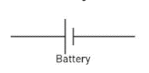

½ mark per correct symbol (max 2)

½ mark correct order

½ mark for series

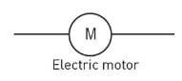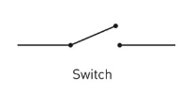

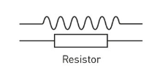

1. A circuit with a power source in parallel with a globe and a bell, with a switch that controls both the globe and the bell. (3)
2. 



½ mark per correct symbol (max 2)

½ mark correct order (switch on either side)

½ mark for parallel

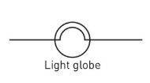

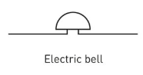

1. A battery in series with a closed switch and a globe, in parallel with a 20 ohm resistor and a globe in series. (4)

½ mark per correct symbol (max 2½) couldn’t be bothered finding a closed switch image – should be closed in diagram

½ mark correct order (switch on either side)

½ mark for correct circuit type

½ mark for 20 Ω on resistor







20 Ω

**Question 6: Measuring Current and Voltage**

Look at the circuit below and answer the questions that follow.

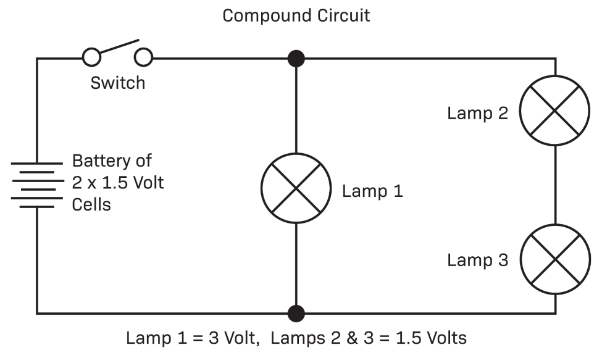

Globe 3

Globe 2

Globe 1

1. Redraw the circuit to include an ammeter to measure the current of globe 1 and a voltmeter to measure the voltage of globe 3. (2)

Correct ammeter position (1)

Correct voltmeter position (1)

1. Explain how and why you placed the ammeter where you did in the circuit. (2)

In series with the globe (1)

Electrons must pass through the ammeter in order to read the flow rate / speed / or similar (1)

1. Explain how and why you placed the voltmeter where you did in the circuit. (2)

In parallel to the globe (1)

To measure the difference in potential energy it needs to be connected before and after the globe (1)

1. 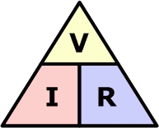Use the formula to complete the Ohm’s Law calculations. (5)
   1. A light bulb has a resistance of 10 ohms and a voltage of 50 volts. What is the maximum current that can flow through the light bulb?

|  |  |  |  |
| --- | --- | --- | --- |
| **Given** | **Equation** | **Work** | **Final Answer** |
| V = 50 V  R = 10 Ω  I = ?  ½ mark | I = V / R  ½ mark | I = 50 / 10  ½ mark | I = 5 A  1 mark  - ½ if no units |

* 1. A toaster produces 12 ohms of resistance in a circuit. If the current through the toaster is 10 Amperes, what is the voltage of the circuit?

|  |  |  |  |
| --- | --- | --- | --- |
| **Given** | **Equation** | **Work** | **Final Answer** |
| V = ?  R = 12 Ω  I = 10 A  ½ mark | V = I * R  ½ mark | V = 10 * 12  ½ mark | V = 120 V  1 mark  - ½ if no units |

**End of Test**

**Multiple Choice**

**Do not write on this sheet. Circle your choice on the first page of your test paper.**

1. Your hand feels cold as an ice-block melts on it. Identify the correct explanation for this process.
   1. Thermal energy transfers from the ice-block into your hand by conduction.
   2. Thermal energy transfers from your hand to the ice-block by conduction.
   3. Thermal energy transfers from the ice-block into your hand by radiation.
   4. Thermal energy transfers from your hand to the ice-block by radiation.
2. Pool blankets are used to trap heat in a pool overnight. Four types of pool blanket were tested on identical pools. Each pool was heated to 28°C, and covered with a pool blanket in the evening. The temperature of each pool was measured in the morning. The results are in the table below.

|  |  |  |  |  |
| --- | --- | --- | --- | --- |
| **Pool Blanket** | **Silverline** | **Hot Stuff** | **Luxury Liner** | **Thermospecial** |
| Temperature at 9 a.m. (°C) | 26 | 24 | 25.5 | 23.5 |

The blankets listed in order from most effective to least effective insulator are:

* 1. Hot Stuff, Silverline, Luxury Liner, Thermospecial
  2. Silverline, Luxury Liner, Hot Stuff, Thermospecial
  3. Luxury Liner, Thermospecial, Hot Stuff, Silverline
  4. Thermospecial, Hot Stuff, Luxury Liner, Silverline

1. A puddle dries up when it absorbs heat from the sun. Which method of heat transfer is causing this to happen?
   1. Convection
   2. Radiation
   3. Evaporation
   4. Conduction
2. Which statement about conventional current and electron flow is correct?
   1. Electron flow travels from positive to negative.
   2. Conventional current travels from negative to positive.
   3. Conventional current travels from positive to negative.
   4. They both travel in the same direction.
3. 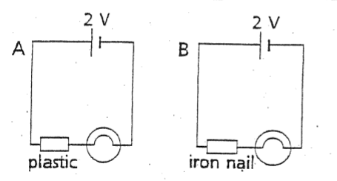Which statement about the two circuits is true?
   1. The globes in both circuits will glow.
   2. The globes in neither circuit will glow.
   3. The globe in circuit A will glow, but the globe in circuit B will not.
   4. The globe in circuit B will glow, but the globe in circuit A will not.
4. A person charges two balloons by rubbing them against their hair. They then held them together. What be most likely to happen?
   1. They will attract each other.
   2. They will repel each other.
   3. Nothing will happen.
   4. The balloons will pop.
5. When the resistance of a circuit increases, the current:
   1. Increases
   2. Decreases
   3. Stays the same
   4. None of the above
6. What is the voltage of an object with 5 amperes of current and 15 ohms of resistance?
   1. 75 volts
   2. 10 volts
   3. 15 volts
   4. 3 volts
7. Which group contains materials that are all good electrical conductors?
   1. Copper, silver, iron
   2. Tin, plastic, iron
   3. Wood, rubber, plastic
   4. Rubber, copper, cardboard
8. The unit used for resistance is the:
   1. Ohm
   2. Volt
   3. Ampere
   4. Joule